STUDENT PERFORMANCE ANALYSIS
Using IBM SPSS Modeler
Dataset: Student Performance Dataset

- Objective
To analyze student performance using IBM SPSS Modeler and classify students into Pass and Fail categories using a decision tree model.
- Dataset
Dataset: Student Performance Dataset
Total Records: 395
Target Variable: Performance
Target Classes: Pass, Fail
- Tools Used
IBM SPSS Modeler
C&R Tree (Decision Tree)
Student Performance Dataset

SPSS Modeler Workflow

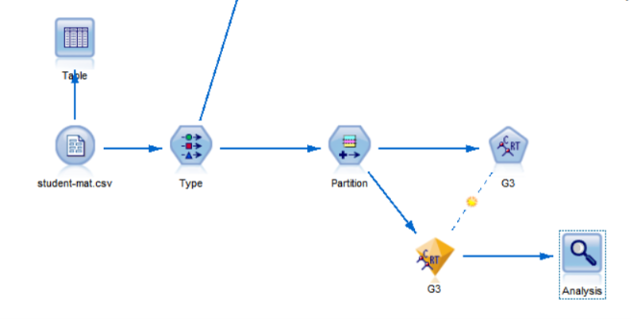

Workflow Description:
The dataset was imported into IBM SPSS Modeler. The data was prepared using the Type and Partition nodes. A C&R Tree model was applied to predict student performance. Performance nodes were used to evaluate the model, and Analysis nodes were used to view the results.

Heading: G3 Decision Tree Model

